N4CSGA EXECUTIVE BOARD ELECTIONS SPRING 2014
Elections for the incoming N4CSGA Executive Board Officers takes place during the Spring Conference. Below are the offices available for the 2014-2015 academic year:

President
Vice-President
Secretary
Parliamentarian
Treasurer
Public Information Officer
Eastern Division Representative
Central Division Representative
Western Division Representative
Intramural/Extramural Committee Chair
Special Populations Committee Chair
Local Interactions Chair

If you would like to run for an office, please meet with your SGA Advisor to discuss your intent, the duties of the office and its requirements. Please refer to the N4CSGA Constitution and Operational Guidelines for more information regarding duties, elections, and campaigning.

Elections
- The qualifications for candidacy as an officer are as follows:
  - Each candidate must possess a 2.5 cumulative grade point average as certified in a letter from the Registrar or Student Records Office of the local institution.

  - Each candidate must be enrolled in at least six curriculum hours of study each semester (summer term excluded) as certified in a letter from the Registrar or Student Records Office of the local institution.

  - Each candidate must provide a letter of nomination from the Dean or his/her professional staff designee of the candidate’s local institution. The letter of nomination must include an agreement by the Dean or his/her staff designee to serve as an advisor to the candidate during the term of office.

  - The candidate’s local institution must provide financial support to attend all N4CSGA Executive Board meetings, divisional meetings and N4CSGA Fall and Spring Conferences.

  - Each candidate must provide the N4CSGA Parliamentarian with a statement of qualifications and a written platform for office.

  - All of these requirements must be met by the fall of the gavel at the first business meeting.

  - Candidates for Treasurer must be eligible and will be bonded by the N4CSGA
- The officers (President, Vice President, Secretary, Treasurer, Parliamentarian, Public Information Officer, Local Interactions Chairperson, and Special Populations Chairperson) of the N4CSGA are elected by the active local institutional membership at the final business session of the annual Spring Conference (to comply with the Constitution).

- The term of office shall be from Transition and Bonding following the Spring Conference through orientation of new officers the following year.

- Officers will be administered the oath of office at the final business session of the annual Spring Conference.

- The exchange of official N4CSGA files, correspondence and records shall take place at the transition phase of Transition and Bonding. Transition and bonding shall be coordinated by the Advisory Council for the incoming officers no later than June 15 following the close of Spring Conference.

- The N4CSGA Executive Board elections shall be conducted by the N4CSGA Parliamentarian of the outgoing Executive Board. It is the responsibility of the N4CSGAParliamentarian to accept letters of recommendation, institutional financial support verification, grade point average, enrollment verification, platform information and the statement of responsibility to validate the candidacy of each applicant. It is the responsibility of the N4CSGA Parliamentarian to prepare and distribute the ballots and, with members of the Advisory Council, to tally the ballots in the presence of the N4CSGA Spring Conference assembly.

- Each institution shall have one vote for each office of the Executive Board. The head of the delegation as declared on the conference registration form shall be issued the ballot, indicate the vote of his/her institution in consultation with the institutional delegation and submit the ballot to the N4CSGA Parliamentarian during the last business session of the N4CSGA Spring Conference.

- In case of a tie, the N4CSGA Parliamentarian is required to vote to break the tie.

- In cases where the N4CSGA Parliamentarian is a candidate for office, he/she must abstain from any official role in the election of any N4CSGA Executive Board member, and it is the responsibility of the current N4CSGA Executive Board to identify one of its members who is not affiliated with the campaign of any candidate to accept these responsibilities.

Division Representatives

- Within the state of North Carolina there shall be three (3) regional divisions of the N4CSGA the Central Division, the Eastern Division, and the Western Division.

- These regional divisions shall elect Representatives at the N4CSGA Spring Conference. Each Division Representative may appoint a secretary to assist with the business functions of the division.

Campaigning

- Posting of campaign materials are to meet requirements set forth by the hotel at which Spring Conference is being held. Any materials not meeting these requirements will be reported to the Advisory Council for removal.

- All candidates will be required to attend a meeting with the Advisory Council prior to the opening session of Spring Conference. The Advisory Council will outline acceptable times for campaigning.

- Members of the N4CSGA Executive Board shall refrain from endorsing any candidate for office.

N4CSGA Executive Board

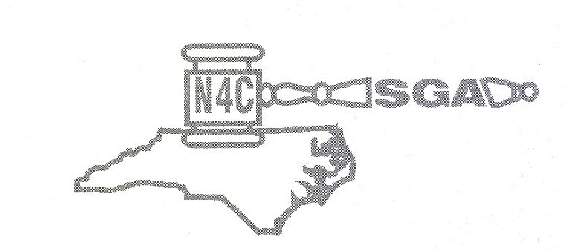
Candidate Information

Qualifications for Candidacy
    - Each candidate must possess a minimum of a 2.5 cumulative grade point average as certified in a letter from the Registrar or Student Records Office of the local institution.
    - Each candidate must be enrolled in at least six (6) curriculum hours of study each semester (summer term excluded) as certified in a letter from the Registrar or Student Records Office of the local institution.
    - Each candidate must provide a letter of nomination from the Dean or his/her professional staff designee of the candidate’s local institution. The letter of nomination must include an agreement by the Dean or his/her staff designee to serve as an advisor to the candidate during the term of office.
    - The candidate’s local institution must provide financial support to attend all N4CSGA Executive Board meetings, divisional/committee meetings, and N4CSGA conferences.
    - Each candidate must provide the N4CSGA Parliamentarian with a statement of qualifications and a written platform for office.
    - All of these requirements must be met by the fall of the gavel at the first business session of the N4CSGA Spring Conference.

Election Speech
    - Each candidate will be given the opportunity to make a very short speech during the Spring Conference. This is your opportunity to inform the delegates of your platform.

Campaigning Guidelines
    - Campaigning will only be allowed during the evening entertainment activities. Appropriate campaigning activities include talking to delegates, handing out information, wearing candidate T-shirts, etc.
    - Candidates and their supporters may not post any flyers or other posters for campaigning at any time in the hotel. The Sheraton Imperial has a strict policy regarding postings.
    - Candidates and their supporters may not hand out campaign materials, wear election T-shirts, etc. at any other time during the conference other than entertainment.
    - Members of the current N4CSGA Executive Board may not endorse any candidate for office at any time during the conference. However, if a current member of the board is running for election, that candidate alone may campaign during the appropriate and designated times for campaigning.

Mandatory Retreat
    - Those students who are elected to a position on the board are required to attend the entire N4CSGA Executive Retreat, scheduled for the first week of June. Any student who is elected, but does not attend this retreat will not remain in office.

I certify that I have read this information and will act in accordance with these guidelines.

Candidate Signature Date

